DOCKER DOCUMENT

Document Properties
Version | 1.0
Date | [Publish Date]
Author | Kumar, Ajit
Project | APTIV-TCI Dev
Category | [Category]
Status | [Status]
Clearance | Internal distribution only

INTRODUCTION TO DOCKER

Docker is a tool designed to make it easy to deploy and run application using container.
Container allow a developer to package up an application with all the parts it needs ,such as libraries and other dependencies and ship it all out as one package.
Developer put all software and components into one container.
Docker will take care of shipping these container into all possible platform in standard ways.
Docker is present in entire workflow like Design, Development, Deployment and Testing/release.
But it’s main use is in Deployment.
Docker is world’s leading Software container platform.
The whole idea of Docker is for developers to easily develop applications ,ship them into containers which can then be deployed anywhere.

INSTALLATION AND SETUP

- Docker For Windows : Docker has out-of-the box support for windows 10
You can download Docker of Windows from
https://docs.docker.com/docker-for-windows/

- Docker Toolbox : Docker toolbox has been designed for older version of windows , such as Windows 8.1 and Windows 7 (Windows 10 also)
You can download Docker Toolbox from
https://www.docker.com/products/docker-toolbox

WHAT TO KNOW BEFORE YOU INSTALL(IMPORTANT)

- Docker for Windows requires Microsoft Hyper-V to run. The Docker for Windows installer enables Hyper-V for you, if needed, and restart your machine.

- Virtualization must be enabled in BIOS and CPU SLAT-capable. Typically, virtualization is enabled by default. This is different from having Hyper-V enabled.

DOCKER TOOLBOX (DOCKER INSTALLATION IN WINDOWS 7 AND 8)

- Docker Toolbox provides a way to use Docker on Windows systems that do not meet minimal system requirements for the Docker for Windows app.
- You can download Docker Toolbox from-https://www.docker.com/products/docker-toolbox
- Once the installer has been downloaded, double-click it to start the installer and then follow the steps given below.
Step 1: click the next button on the start
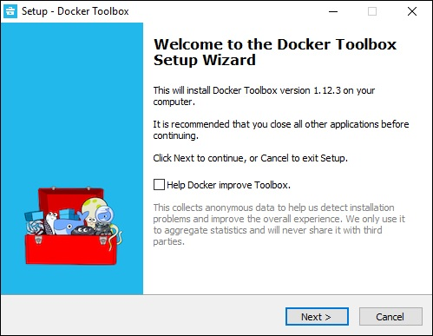

Step2 : Keep the default location on the next screen and click the next button.

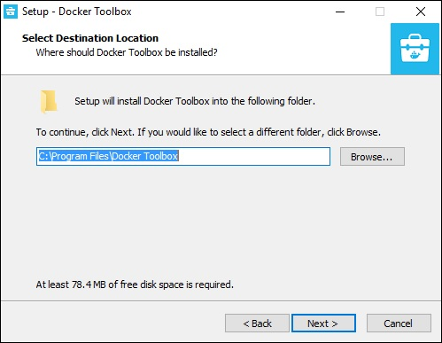

Step 3 : Keep the default component and click next button to proceed.

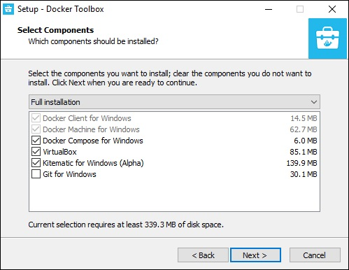

Step 4 : Keep the additional task as they are and click next button

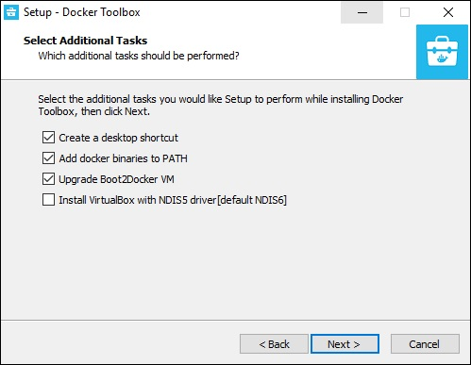

Step 5 : On the final screen click the install button :

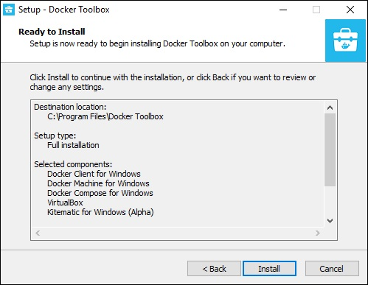

The Installation adds the following software to your machine
- Docker Client for Windows.
- Docker Toolbox management tool and ISO.
- Oracle VM VirtualBox.
- Git MSYS-git UNIX tools.

Verify your installation
- On your Desktop, find the Docker QuickStart Terminal icon.
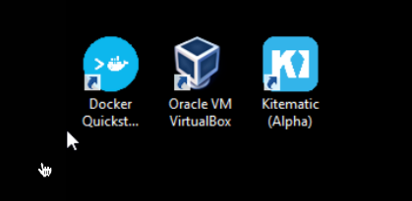

- Click the Docker Quick Start icon to launch a pre-configured Docker Toolbox terminal.
- Next, you will see the configuration being carried out when Docker toolbox is launched.
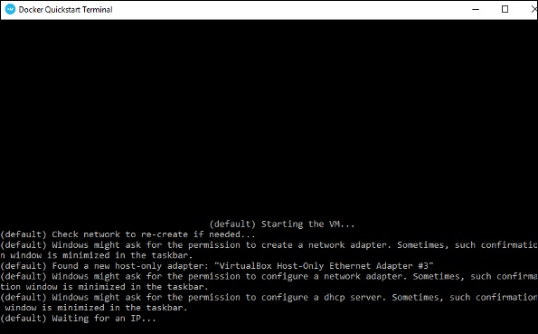
- Once done, you will see Docker configured and launched. You will get an interactive shell for Docker.
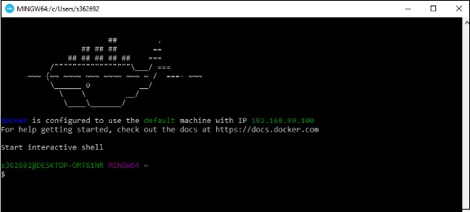
- To test that Docker runs properly, we can use the Docker run command to download and run a simple Hello-World Docker container.
- $ docker run hello-world.
- This command will download the hello-world image, if it is not already present, and run the hello-world as a container.
When we run the above command, we will get the following
result −
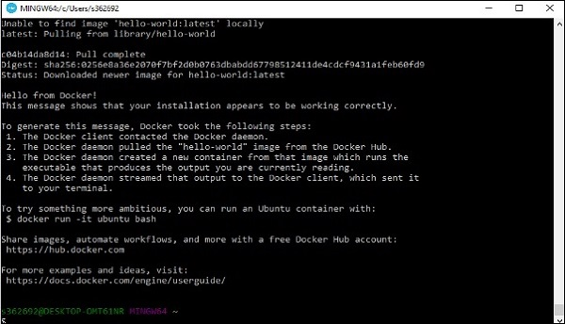

TROUBLESHOOTING
If latest Boot2Docker.iso file is needed for
docker we can download from-
https://github.com/boot2docker/boot2docker/releases
and Paste it in the path as mentioned below.
C:\Users\wj468l\.docker\machine\machines\default

DOCKER INSTALLATION FOR WINDOWS 10
Step 1 : Click on the agreement terms and then the install button to proceed ahead with the installation.

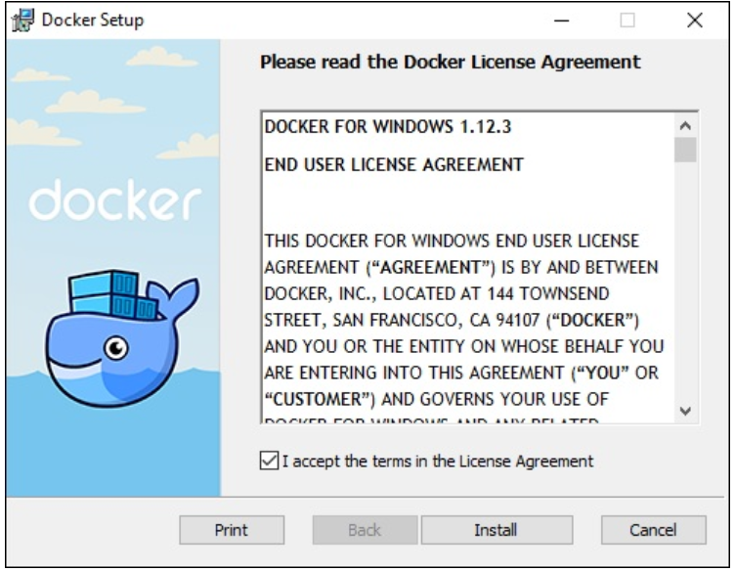

Step 2 : Once complete , click the finish button to complete installation
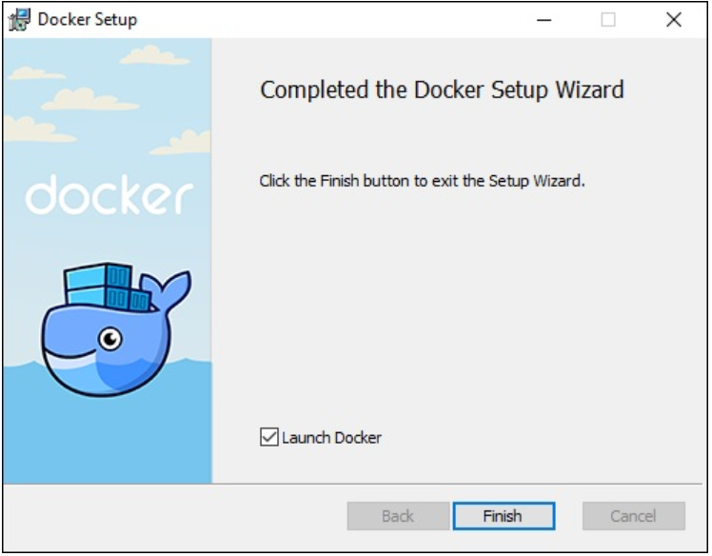

DOCKER INSTALLATION UBUNTU
The Docker installation package available in the official Ubuntu 16.04 repository may not be the latest version. To get this latest version, install Docker from the official Docker repository. This section shows you how to do just that.
First, in order to ensure the downloads are valid, add the GPG key for the official Docker repository to your system:
curl -fsSL https://download.docker.com/linux/ubuntu/gpg | sudo apt-key add –
Add the Docker repository to APT sources:
sudo add-apt-repository "deb [arch=amd64] https://download.docker.com/linux/ubuntu $(lsb_release -cs) stable"
Next, update the package database with the Docker packages from the newly added repo:
sudo apt-get update
Make sure you are about to install from the Docker repo instead of the default Ubuntu 16.04 repo:
apt-cache policy docker-ce
You should see output similar to the follow:
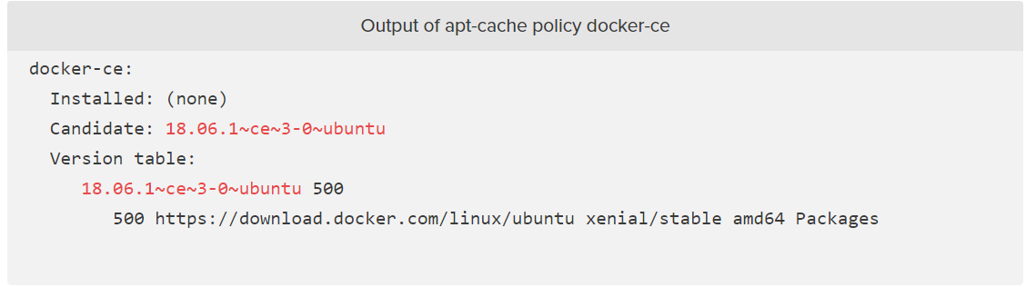
Finally, install Docker:
sudo apt-get install -y docker-ce
Docker should now be installed, the daemon started, and the process enabled to start on boot. Check that it's running:
sudo systemctl status docker
The output should be similar to the following, showing that the service is active and running:
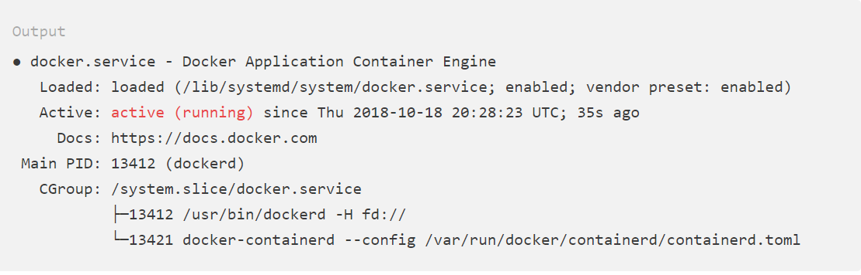
If you want to avoid typing sudo whenever you run the docker command, add your username to the docker group:
sudo usermod -aG docker ${USER}

DOCKER INSTALLATION CENTOS

The Docker installation package available in the official CentOS 7 repository may not be the latest version. To get the latest and greatest version, install Docker from the official Docker repository. This section shows you how to do just that.
But first, let's update the package database:
sudo yum check-update
Now run this command. It will add the official Docker repository, download the latest version of Docker, and install it:
curl -fsSL https://get.docker.com/ | sh
After installation has completed, start the Docker daemon:
sudo systemctl start docker
Verify that it's running:
sudo systemctl status docker
The output should be similar to the following, showing that the service is active and running:
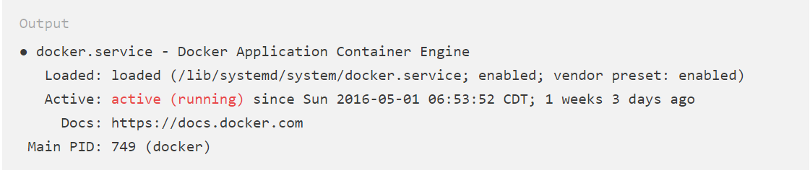
Lastly, make sure it starts at every server reboot:
sudo systemctl enable docker

If you want to avoid typing sudo whenever you run the docker command, add your username to the docker group:
sudo usermod -aG docker $(whoami)

